IDEATION PHASE
Idea Prioritization

Date
Team ID | 6aba09485015c35b9862c9ac
Project Name | FitBuddy – AI Fitness Plan Generator using Gemini Models
Maximum Marks

Idea Prioritization
Brainstorming provides a creative and collaborative environment where team members can share ideas, identify user needs, and develop innovative solutions to real-world problems. For the FitBuddy project, brainstorming helps the team explore different ways of using Artificial Intelligence and Gemini models to create personalized and practical fitness plans.
The team focuses on generating multiple ideas before selecting the most suitable solution. Ideas related to user profiles, fitness goals, personalized workout planning, activity tracking, AI-based recommendations, progress monitoring, and user-friendly interaction are discussed and evaluated.
FitBuddy aims to simplify fitness planning by allowing users to provide their basic preferences and fitness goals, after which the AI generates a structured and personalized fitness plan. The system is designed to provide general wellness guidance while encouraging users to make safe and informed choices.

Reference

Step-1: Team Gathering, Collaboration and Select the Problem Statement
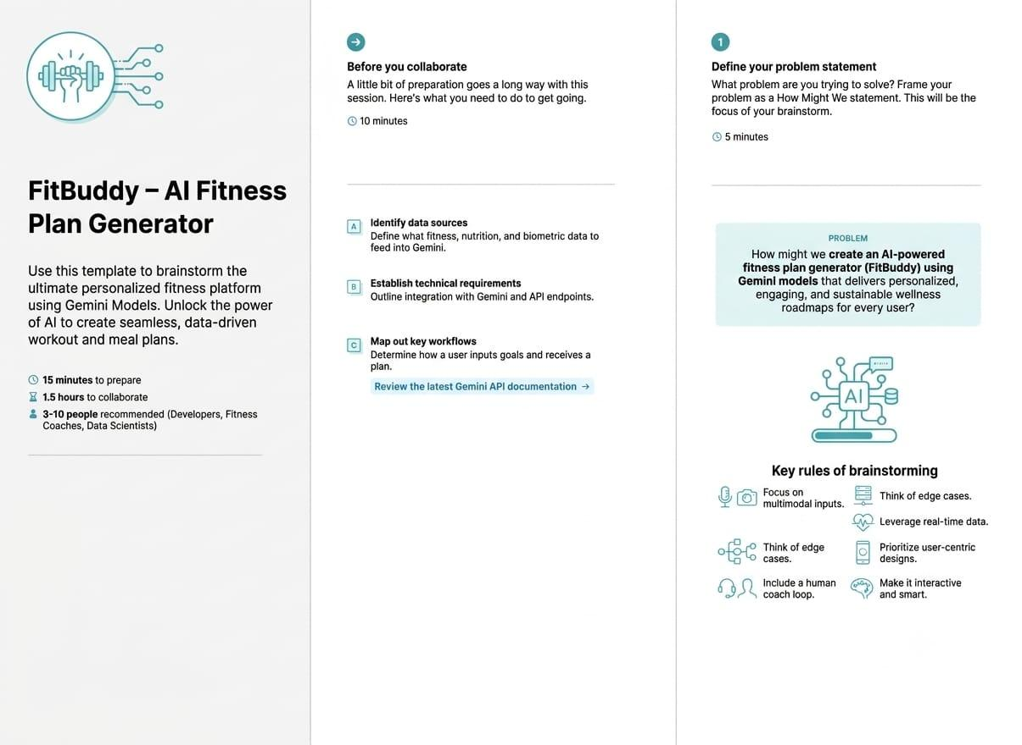

Step-2 : Idea listing and Grouping
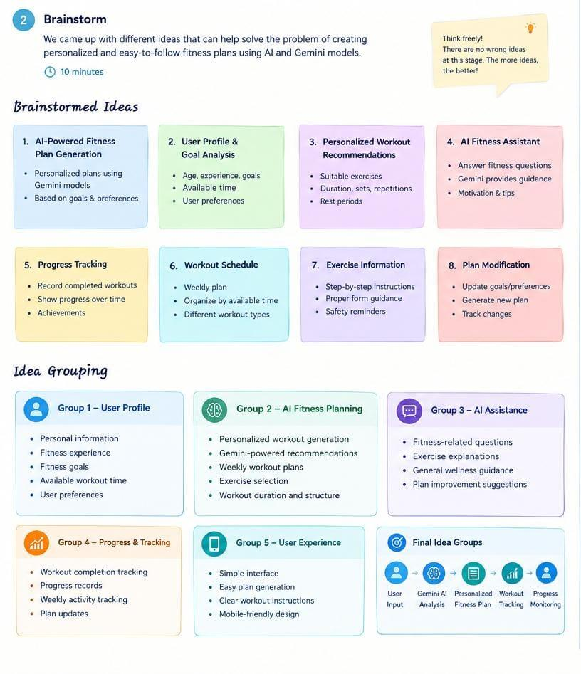

Step-3: Idea Prioritization
